High Resolution Stepper Motor with Mini V2 / V3 Controller
Quick Guide

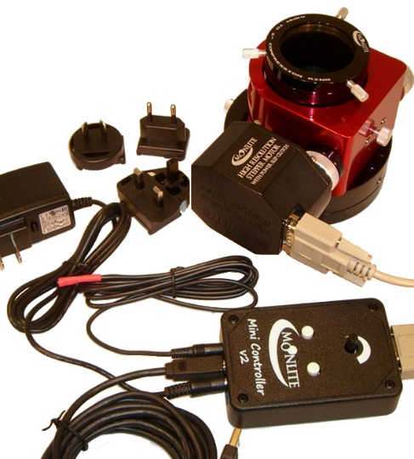
Note: The Mini V2 controller and the new V3 built in controller work exactly the same and use the same Software and drivers.
Test General Operation
- Plug controller and motor in. Connect power and press the white buttons on mini V2 controller to jog focuser in / out.
- Red LED will blink during movement.
- Black knob controls speed of motor.
- Loosen the slip clutch and rack drawtube up down with manual knob. Motor will just slip in this mode if you use the controller. Tighten the clutch back up for motor operation.
- Install Software and USB driver to test basic PC connectivity. See Download Tab for software and instructions.
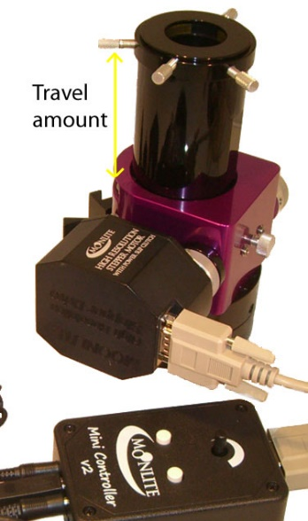
Calculate Number of Steps Possible
- Calculate the number of steps your particular focuser has based on the drawtube travel installed. Note: Step size is = .00016” in full step mode, or .00008” in half step mode.
- Example: a CS model SCT focuser with the .95” travel drawtube installed would have about 5937 steps total.
- A CF model refractor focuser with the 4.5” long travel drawtube installed would have 28,125 steps total.
- You can now estimate how far you will be able to move the focuser before running in to the mechanical stops. Note: no damage will happen when running into the stops, it will simply slip on the slip clutch or shaft drive before harming anything. However, running into the stops after the focuser is calibrated will cause the step count to be off and will require re-setting the zero home positions.
Setting Zero Focus Home Position
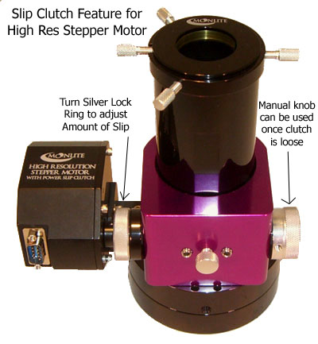
- Rack drawtube the whole way in, either manually with the knobs or holding down the “In” button on the controller.
- Start the MoonLite Non-ASCOM utility program and connect to the controller.
- With the focuser racked the whole way in, press “Null” to make it the zero home position. Zero step count is now set at the racked in position.
- Test the movement of the focuser. Pick a positive number to goto and observe the focuser moving to that step count number. Practice moving the focuser around to get familiar with the application. Note: only positive step counts are supported with Astro focusing software.
- Note: hold clutch ring with left hand and regular knob with right hand.
Turn like a lid on a jar to either tighten the clutch or loosen the clutch.
If the manual knob turns easily, then the clutch is not tight.

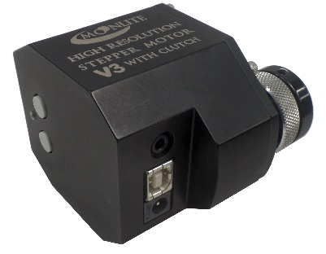
Install the ASCOM driver and set up the focuser for automation using your imaging software. Please note only 1 application at a time can connect to the Mini V2 /V3 /or Dual port controller. Disconnect from the MoonLite Non-ASCOM application before connecting your ASCOM program or SKYX plug in.
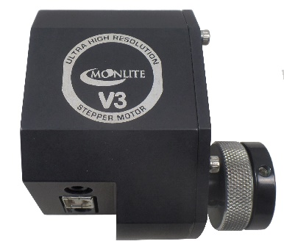
These programs will run on the mini V2 controller, V3, and DRO display controller. Note: the V3 has the USB controller built into the motor case, and has the up/down buttons on the side. There is no speed control knob on the V3 versions , so we configured the up/down buttons on the V3 motor to move slow at first, then ramp up to full speed after a few seconds if continuously pressed. Red LED will blink when in motion.
We also offer an Ultra High res stepper motor version that features a 4-times higher resolution gear box. Great for F3 or faster scopes. The ultra version is $100 more and also uses all of the same SW and drivers as the regular Mini V or V3 versions. Ultra version will provide .00004” per step in full step mode and .00002” per step in half step mode.
Go to the Download tab on the www.focuser.com page and download and install 3 items.

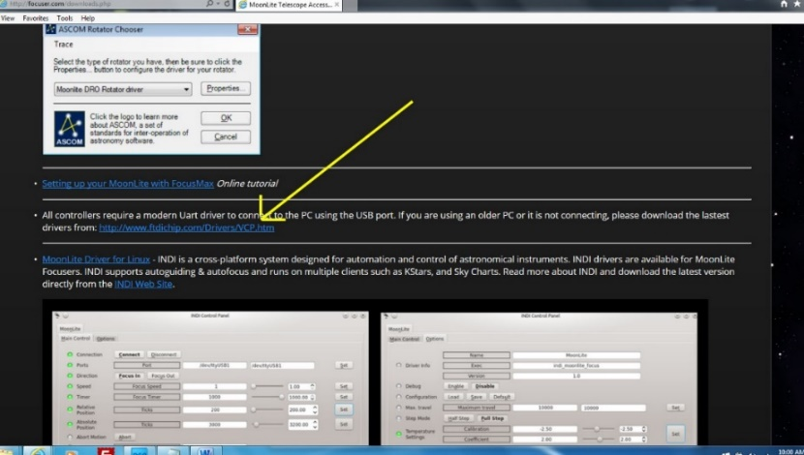

Ftdichip driver for the USB port

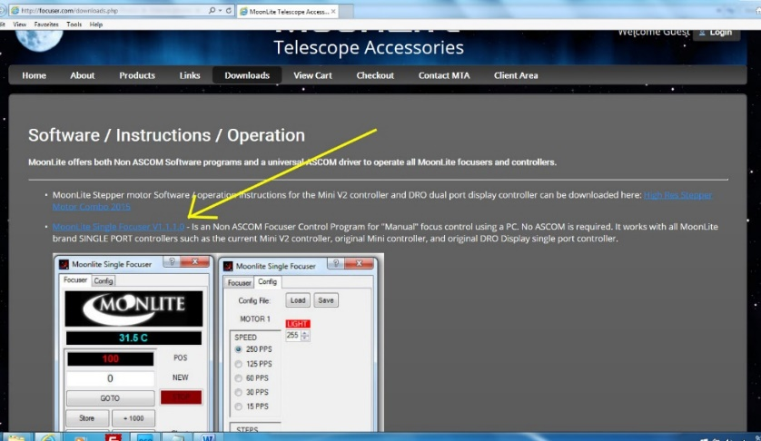

Moonlite Non-ASCOM utility program

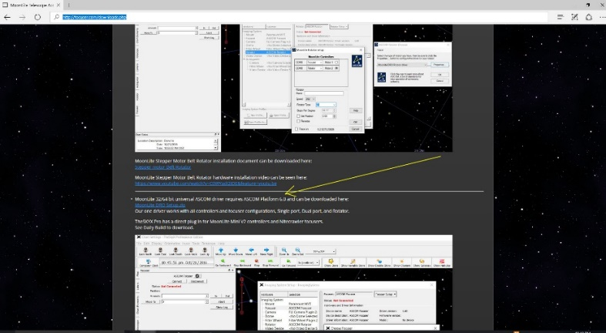

ASCOM Driver

MoonLite NON-ASCOM Utility Program Version 1.4
See Download Tab for installation

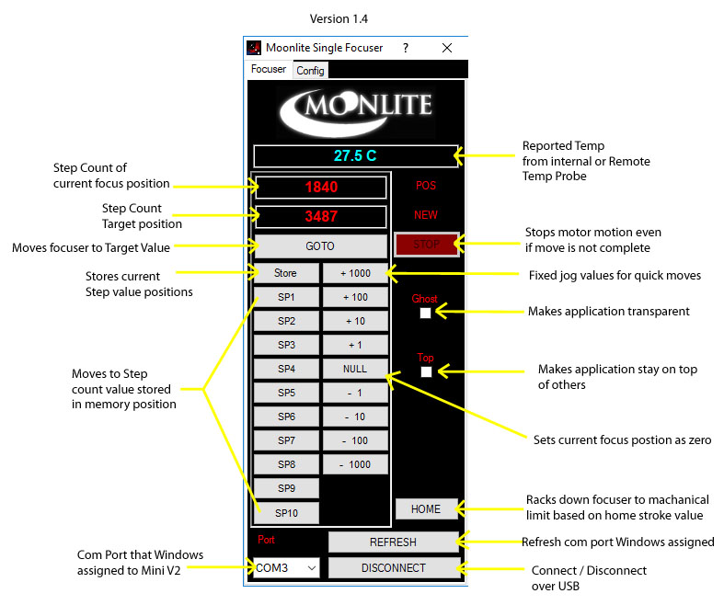
This application is provided for basic operation / testing of the focuser with no ASCOM required. However, most customers will be running ASCOM. Please make sure you have ASCOM 6.2 platform installed and our ASCOM Driver. The mini V2 controller will work fine under all ASCOM based programs.

The SP1-8 buttons can be used to store step count positions. Move the focuser to the current desired position and press the store button and then one of the SP buttons. The step count value will be stored temporarily into the button until the application is closed. To save SP memory positions, use the store and save button in the configuration tab. You can also rename the buttons if you open the stored file with notepad and rename the buttons / or even the step count. However, you will need to load the file each time you start the application.
The Home button allows the focuser to be remotely Homed or “Zeroed”. When clicked, the focuser will rack down past the value set in the config tab’s “Home Stroke” box. The number of steps entered into the Home stroke box should be greater than the total steps the focuser can move. Example: for a .95” travel drawtube that provides 5937 steps, enter a value of 6200 in the Home stroke box. That will ensure the focuser will rack down to the stop and be completely zeroed out. Remember the focuser will simply slip when hitting the stop causing no damage.
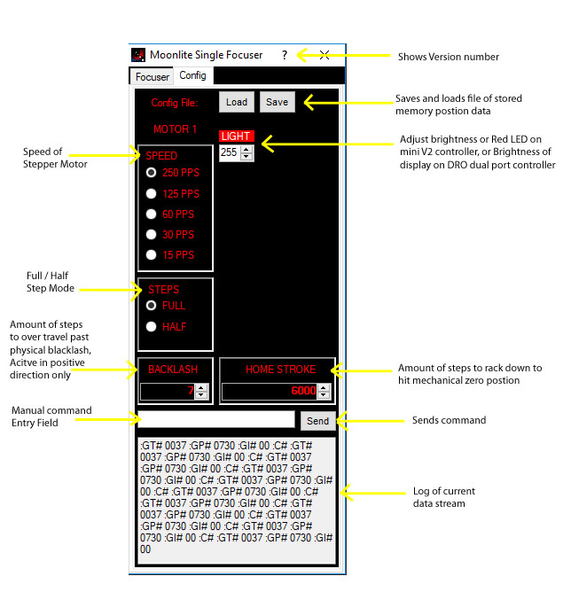
Configuration Tab
Backlash value will allow the focuser to overshoot positive moves by the value set in the box, then come back to the target move. This will take any backlash out that may be present, as the move is always pulling the load up in the same direction every move. Just enter a value greater than the backlash amount observed. Normally, a value of 5 to 10 is plenty larger than the actual backlash of the motor.
It is possible to send basic raw commands to the controller using the field box and the send button. Please see high resolution stepper motor document for a full list of commands. This is provided for more advanced users.

MoonLite Telescope Accessories
475 Preserve Road, Danville, PA 17821-7971
570-437-2232
www.focuser.com

